Tonight's Cast
Emcees Brandon as Justin Bieber
Tracy as Tommy Wiseau
Trixie Courtney as Sarah Palin
Frank N. Furter Diego as Courtney Love
Brad Majors Bill as Genghis Khan
Janet Weiss Megan as Britney Spears
Riff Raff Paco as Dwight Schrute
Magenta Terry as Snooki Polizzi
Columbia Stezy as Paris Hilton
Dr. Scott Tim as Charlie Sheen
Eddie Wade as Glenn Beck
Rocky Sidell as Tiger Woods
Crim Leif as Guy Fieri
Phantom TBA

Transylvanians

Cheryl Poncho Jesus Andrew
Peter Jordan Carlos Kayla Jessika

As The Westboro Baptist Church

Midnight Mafioso
Stage Director: Brandon Stage Director: Mandi Technical Director: Zac Inventory: Aleah
Tranny Coordinator: Cheryl Webmaster: Bill
Sound: Leif & Tracy Secretary: Aleah
Accountant: Kim Juu Photographers: Liz & Kate
Props Foxes: Jo & Shevaun House Manager: Tracy & Drew
Security: Jasmine, Fluffy, Data
Merchandise: Jenna, Dakota, Amy, Jordan
Spotlights: Kim, Lara, Nikkie, Kate, Jenni
Scenic Tech: Zac, E van, Eddie, Siddell
Denton Times
www.midnightinsanity.org
Hey there, ladies and gents, and welcome to another ridiculous night at Midnight Insanity. This Saturday, we celebrate the audaciousness of American pop culture by bringing you twelve of the most offensively AWFUL people creeping around the world today...and one Mongolian emperor from the 13th century. Be prepared to sit back and enjoy some good old offensive behavior, at the expense of some asshole celebrities.
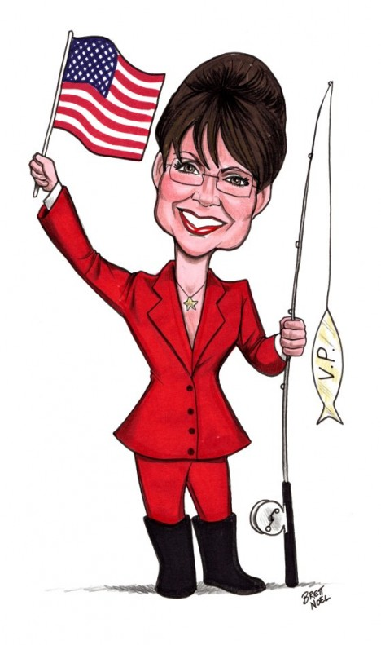
We've been getting so many requests for our next theme night, we HAD to plan this one a couple of months early. Be sure to clear your calendar for May 14th, because Midnight Insanity will be bringing back 80's Night!! That's right, come celebrate the decade that most of you were born in (or after...*sigh*)by whipping out the hairspray, pulling on the shoulder pads, and breaking out the neon. This is a night you DON'T want to miss.

Have some suggestions for our show? Some merchandise you'd like us to sell? A prop that we should add to our stage? A performer you're hooked on and just HAVE to see more of? Then shoot an email to brandon@midnightinsanity.org OR mandi@midnightinsanity.org. Hope to hear from you lovely folks.

Like what you see? Want to join the eleganza that IS Midnight Insanity? Well lucky for you, we're always looking for some unsuspecting, innocent fools to corrupt. You don't get paid, but you get invited to our kick ass parties, meet some really awesome people, and you can channel your creativity into something besides that weekly-underwater-basket-weaving-class. So talk to Brandon or Mandi about what you need to do to join our little family...er cult...er cast. Yes, join our happy, harmonious, harmless little cast.

Brandon's Nonsensical Ramblings:
"You need some sort of...epic banana hammock!"

